Assignment 2 Help Document

This help document has been created to show the user that is using our website design, how to set it up in localhost, along with the usernames and passwords for the database itself. I will begin the help file by downloading the folder itself

The file that we download will first come as a zip folder which we will then have to extract all the contents within the zip file so that it can be viewed. We then have to take the folder and place it in our WWW area within our wamp64 folder on our C-DRIVE.

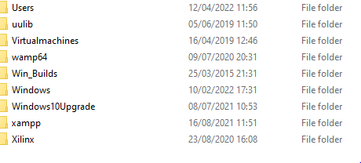

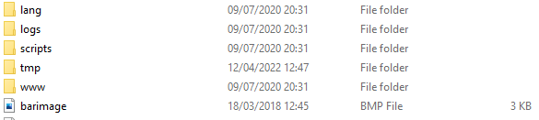

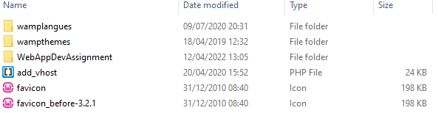

Now that the folder is placed in the correct area we can now look at the database that our group created.

Now open up Wamp and use the username ‘root’ with no password to access your local area. Then press new and pick any name from the database and click create.

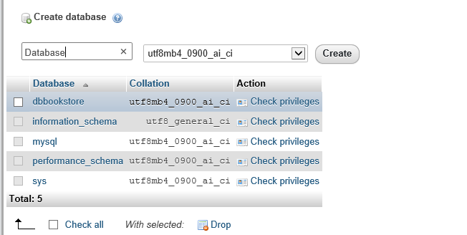

Once we do that we then have to import the SQL file that is contained within all the website files to get the database onto the system that we are using. It will then display this:

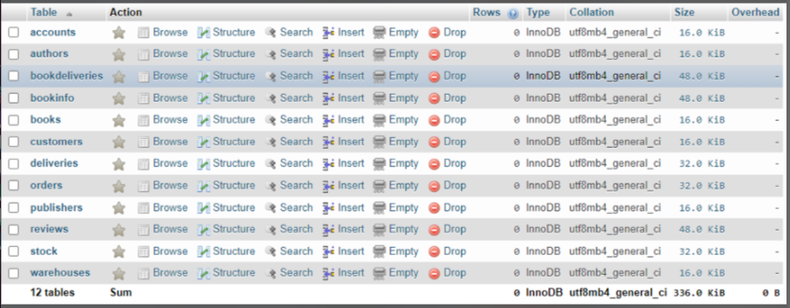

Here is the Entity-Relationship Diagram that we made which shows how the different entities that are in the diagram will relate to each other in the system for our book store. It will show the different primary keys, foreign keys, the different data types such as if the data is text, integers, decimal or date. It will also show the data size of each field. The diagram will also show the different relationships in the database such as one-to-one, one-to-many and many-to-many.

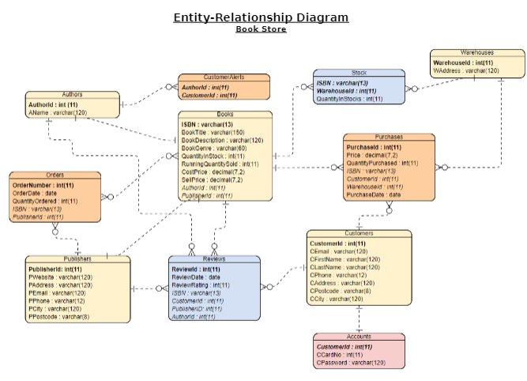

Here is the data dictionary for our bookstore. The data dictionary will contain information such as what is in the database, who is allowed to access it, where the database is stored etc. The user cannot interact with the data dictionary, as it is handled by the database administrators. As you can see from our bookstores data dictionary it will show where all the different data is stored such as accounts, authors, books, customers, orders, purchases, reviews and the different indexes

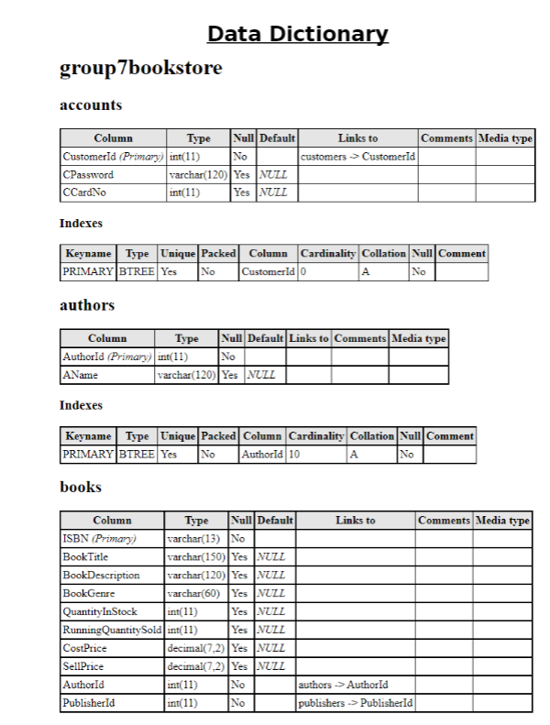

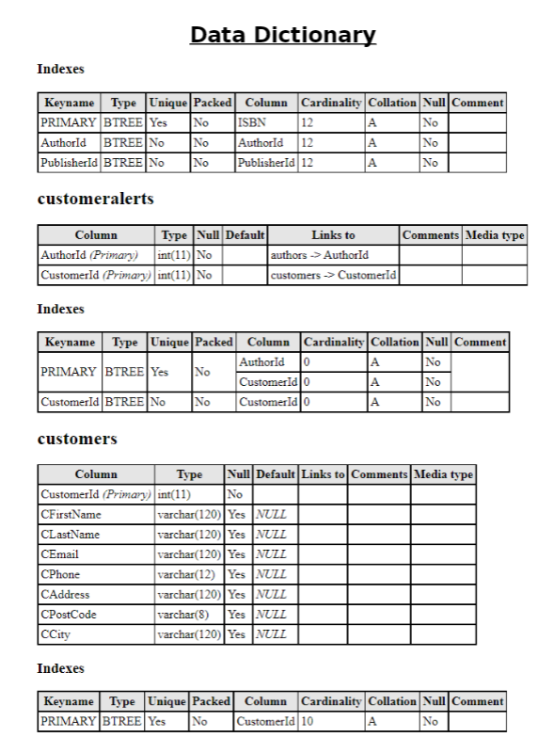

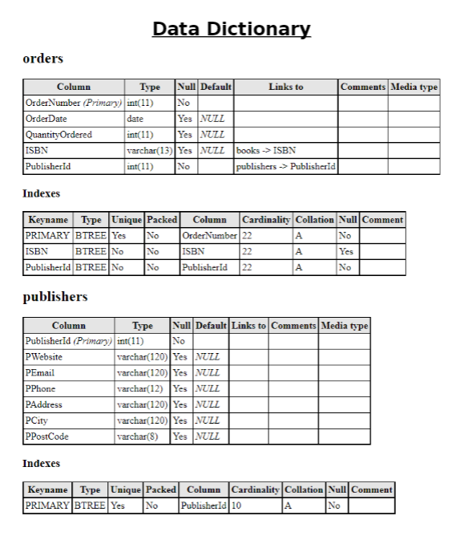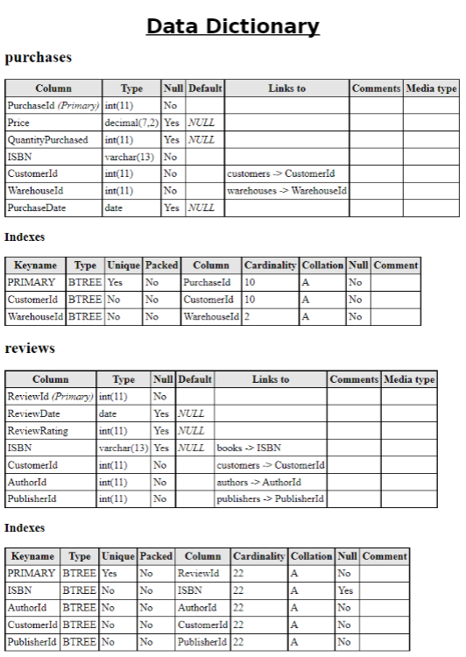

Next is the database schema that we created for our bookstore. The database schema defines how data is organized within a database. This means it will show logical constraints such as table names, fields, data types and the relationships between these entities. As you can see from our database schema it makes it a lot easier to understand what goes into our database and how the different entities will link together using different primary keys and foreign keys. An example of this would be the purchase table. You can see the PurchaseId is the primary key of that table and will display different data types such as the price, quantity purchased and purchase date. It will then pull in data from the customers table using the foreign key CustomerId which will then create a one to many relationship, linking them together along with other foreign keys in the purchase table such as ISBN and WarehouseId.

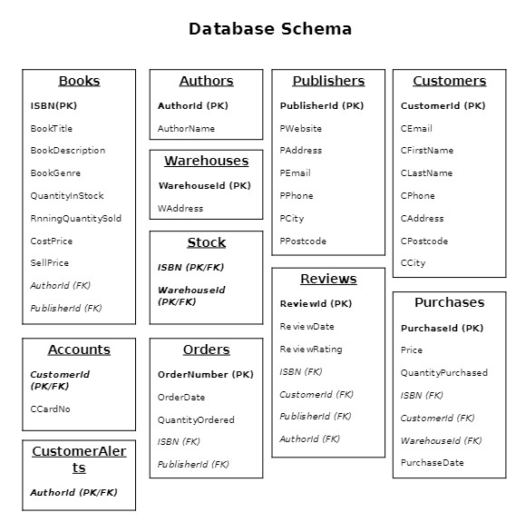

Now I will show that our database is working on Amazon Web Services. Firstly follow this link https://www.awsacademy.com/LMS_Login. Then to login to AWS to view the bookstore database you will need the username and password:

The credentials for Amazon Web Services are:

Username: admin_336

Password: groupseven

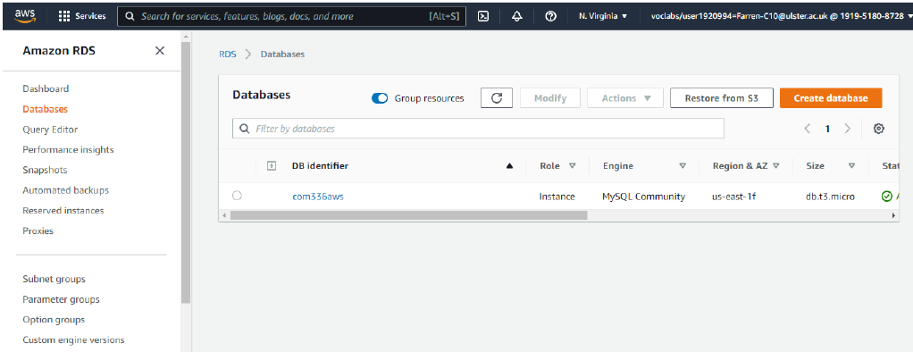

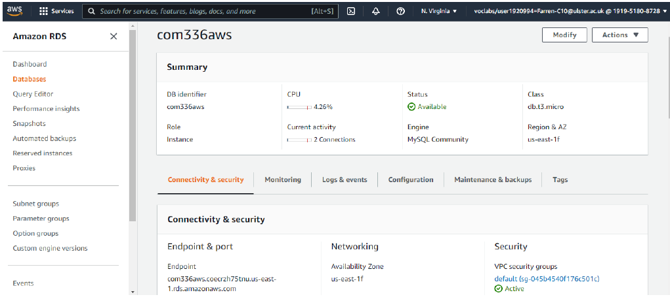

Once logged onto the root user, you will be able to see the database fully working and functional on AWS RDS where you can access and edit the full database as seen above.

The database is hosted on “US-EAST-1A” referring to Virginia (United States). The reason for this decision was because it is the default choice. But you could also choose the closest location to our region, which could potentially offer low latency and cheaper option.

The final screenshot below shows the database running on SQL Workbench and correctly connected to AWS RDS services. This is easily accessible by launching MySQL Workbench, adding a new MySQL connection, changing port to 3306, specifying the unique username & testing the connection.

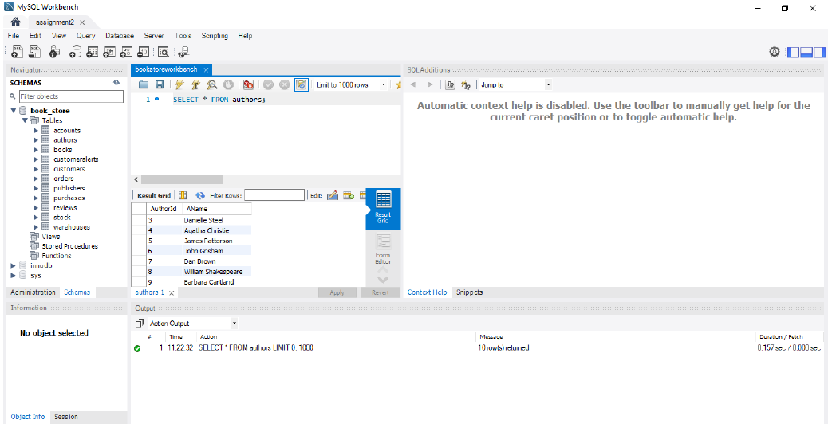

In the screenshot above, we have clearly shown a query being run on the SQL Workbench application, and so proving that the database is able to be edited successfully.

**Overview:**

Step by step process of this group project:

Week 1: Swapping contact information & introductions via Slack.

Week 2: Research & Project Ideas.

Week 3: Topic selection, role allocation & weekly meet-up times.

Week 4: Database Schema creation.

Week 5: E.R Diagram creation.

Week 6: Data Dictionary, PHPMyAdmin database creation & Updates.

Week 7: SQL Queries & Sample data dump.

Week 8: Storyboards for website.

Week 9: AWS Connection.

Week 10: Video walkthroughs & help document.

Week 11: Slack, GitHub & query explanation documents.

Week 12: Peer review assessment & submission.

Web Bookstore Application Project – Group 7:

*Carla Farren*

*Gavin Kelly*

*Matthew Devine*

*Matthew Mulligan*

*Orlagh Mc Closkey*